**CMPUT 275 Final Project Proposal**

**Project Title: Music Decoder**

**Group Members: Ang Li, Matthew Braun**

**Description:**

For our project, we plan on developing a program which can take an mp3 file as input, decode the audio into its various frequencies, and visualize the frequency data onto a spectrum over time as the audio file is playing. We will use external libraries, such as Synthesis Toolkit C++, to analyze the audio file and convert it to numerical data. From there, we will transform this numerical data using the

**Milestones:**

1. By March 21st, 2019, we will be able to convert the signal of a small segment of time, of an audio file, into a 2-dimensional array of several numerical magnitude(dB) data points, over discrete audio signal frequency values.
2. By March 24th, 2019, this program should be able to visualize this data onto a magnitude vs. frequency bar graph, like the graph depicted below:

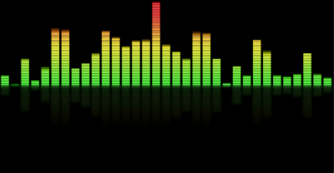

1. By March 29th, 2019, this program should be able to convert an entire audio file into several dB vs. frequency bar graphs, with these graphs quantized over a third dimension, time, in fixed increments, creating an array of graphs over the length of the audio file.
2. By April 2nd, 2019, this program should be able to visualize these graphs as a frame-by-frame animation, displaying each sequential graph in real time, as the chosen audio file is playing in sync with the graph animation, giving the user a frequency visualization of their chosen audio file.
3. If time permits, we will visualize these graphs in other ways, such as mapping each frequency range, greater than a certain decibel threshold, to a specific note on an instrument (e.g. guitar, piano), visualizing the notes one would have to play on said instrument, to play a song, given an mp3 file of the song.